Veterans in Crisis
Are you a Veteran in crisis or concerned about one?
You don’t have to be enrolled in VA benefits or health care to call. There are three ways to reach out.
Dial 988 and Press 1
Text 838255
Online Chat here
For more information visit Veterans Crisis Line

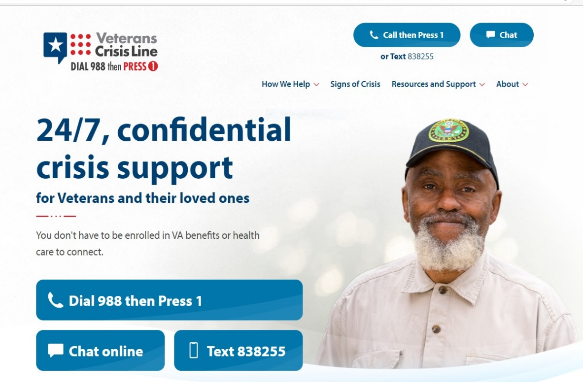

National Call Center for Homeless Veterans
Free Help for Homeless Veterans Call 1-877-4AID VET (877-424-3838)
Veterans who are homeless or at risk of homelessness – and their family members, friends and supports –call or chat online with the National Call Center for Homeless Veterans Trained counselor are ready to talk confidentially 24/7
Who Can Call
- Veterans who are homeless or at risk of homelessness
- Family members, friends and supporters calling on behalf of Veterans
- VA Medical Centers and other VA facilities and staff
- Federal, state and local partners
- Community agencies and providers who serve Veterans who are homeless
Why Make the Call to 1-877-4AID VET (877-424-3838)
- It’s free and confidential
- You’ll get access to trained VA counselors
- It’s available 24 hours a day, 7 days a week
- You’ll get information about VA homeless programs, health care and other services in your area
What Happens When Veterans Make the Call
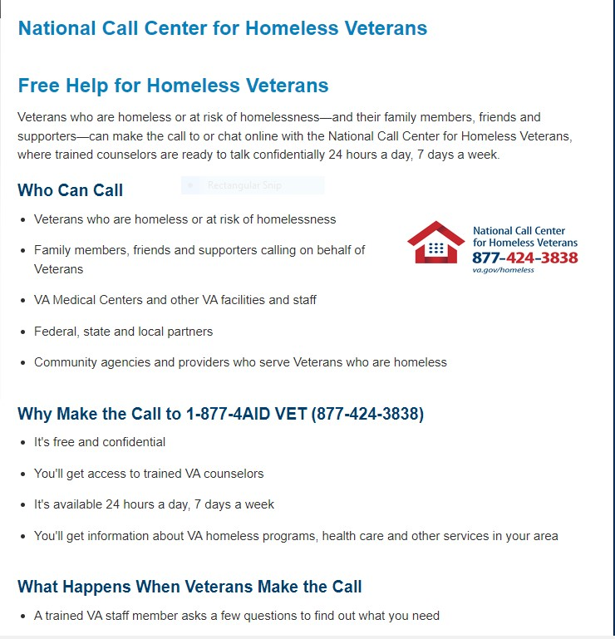
- A trained VA staff member asks a few questions to find out what you need

